Bash 01 task
Execute all scripts shown in video and capture the screenshots.
Step -01
Started with instance and connect to git bash with ssh
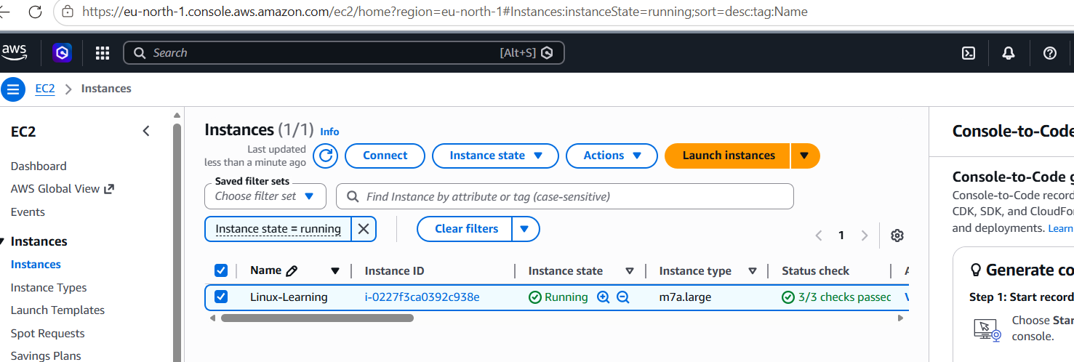
Connected git bash successfully with remote machine and switch user to root.
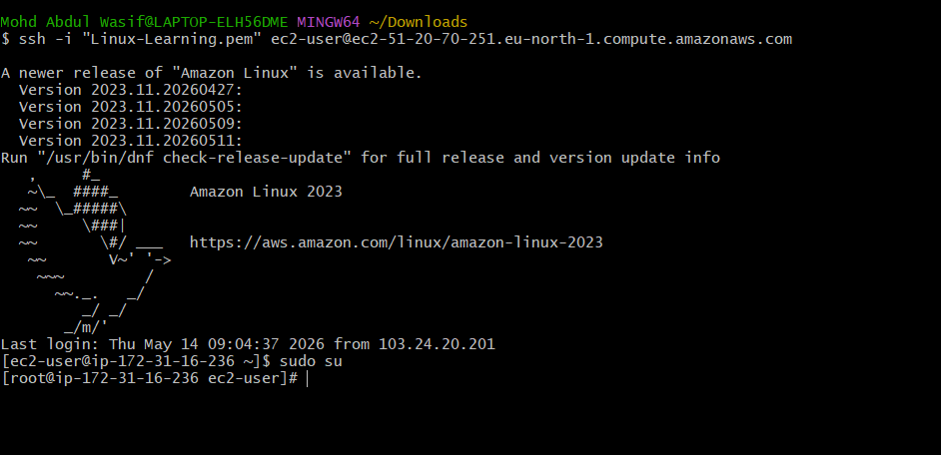
Checked by echo $0 for bash installed
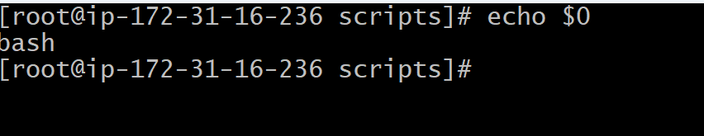
Now created one automation file for daily work command Free -m , ps -ef , df ,du-sk*
then edited (vi test.bash :- #!/bin/bash Free -m , ps -ef , df ,du-sk*)
then I got error for du -sk*
Then I edited du and got successful edit
to check will hit ‘ll’ command
./file name
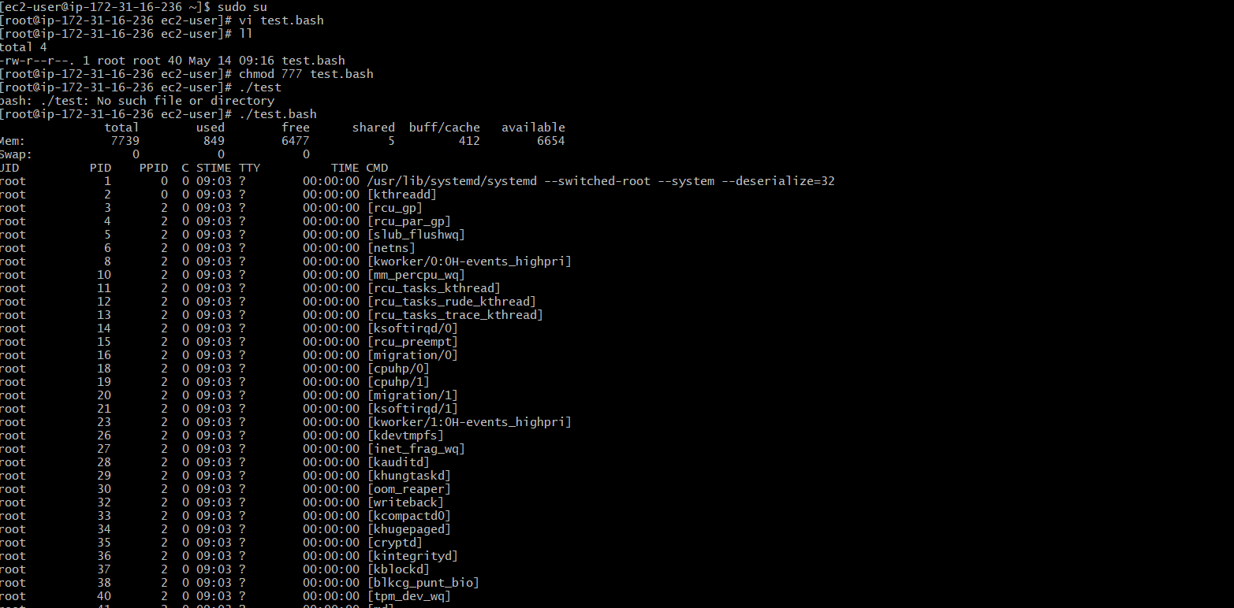
then I got error for du -sk*
Then I edited du and got successful edit
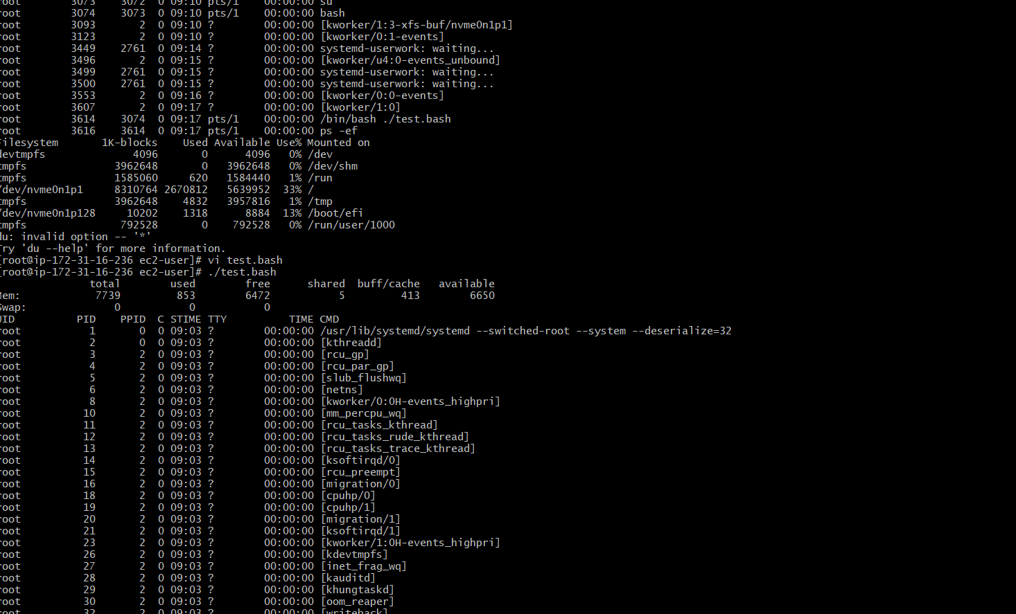
Now above-mentioned command is automated
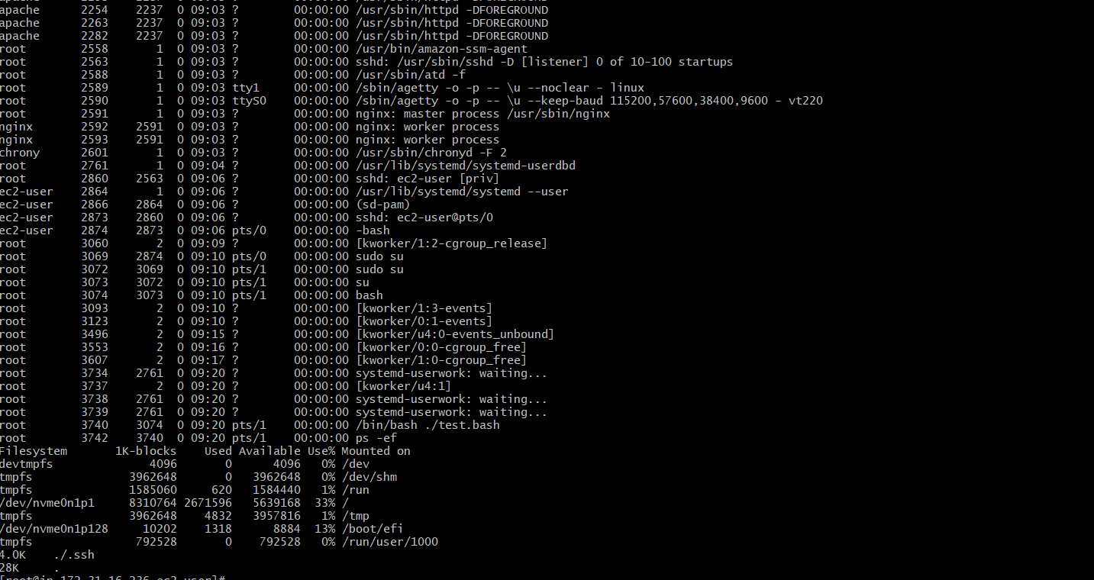

- Execute all the scripts share in devops-cloud-documents-20 channel.
1. Script Basic practice
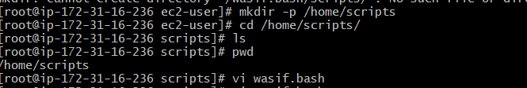
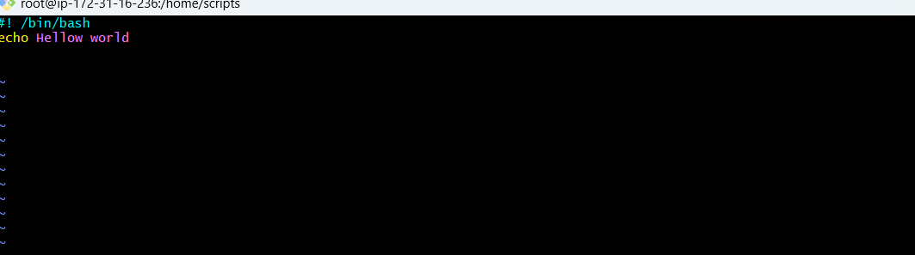
After creating directory when I check by ( ./file name ) got error because I didn’t gave permission
After that I gave permission chmod 777 and I can able to check text of script
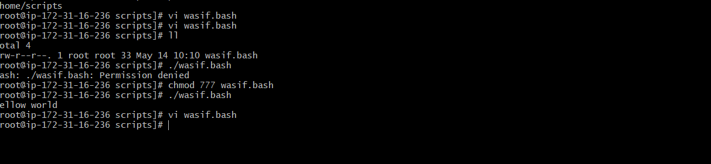

2. Script Basic practice
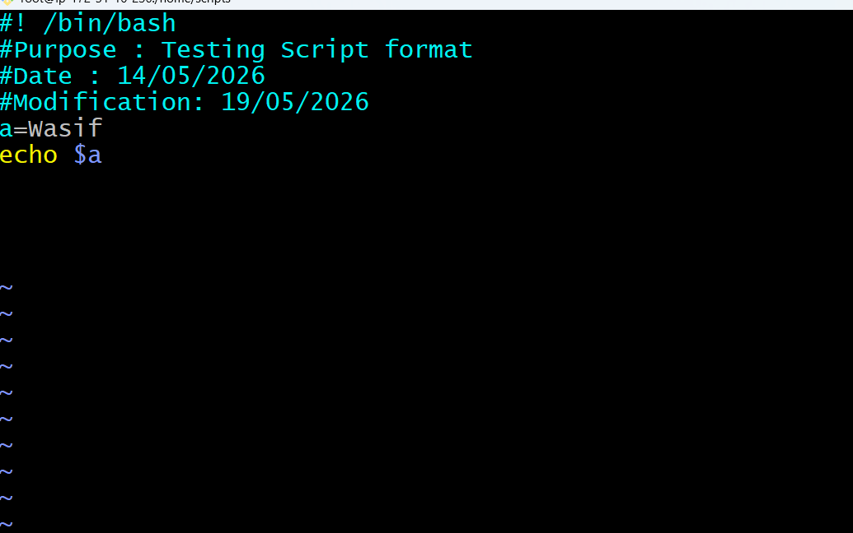
After that I gave permission chmod 777 and I can able to checked script text (./filename)
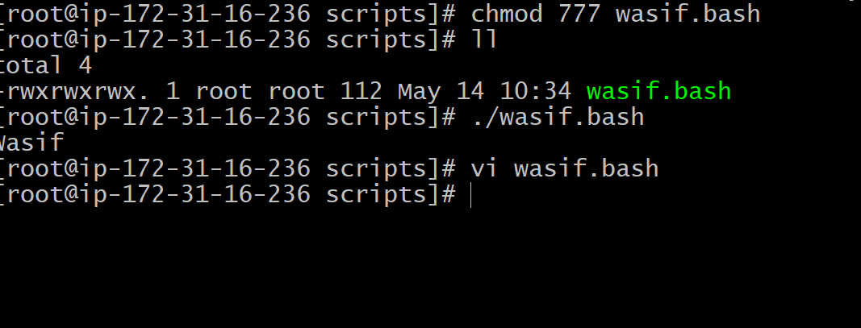
3 Script: Sequence of command
#!/bin/bash
pwd
ls
whoami
date
cal
touch a b c
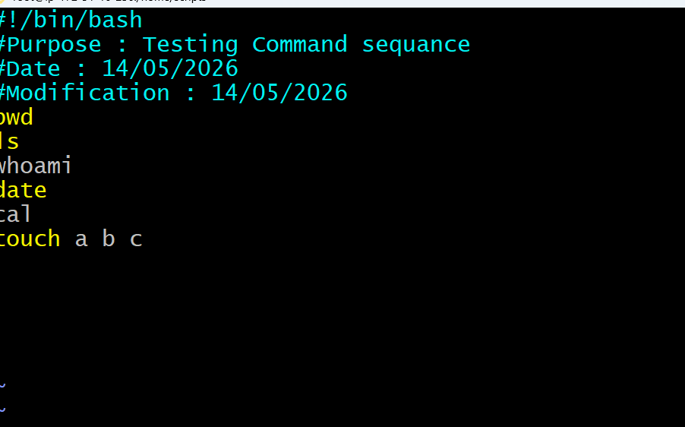

Then cat file, also checked for ls
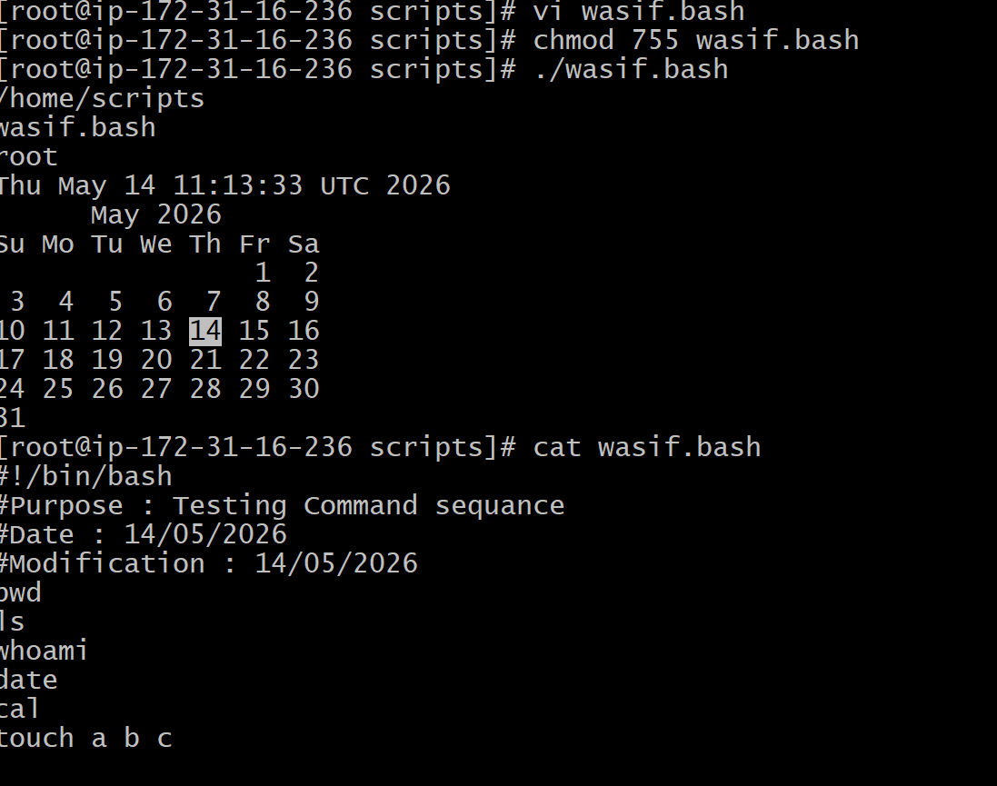
All the command working sequenc
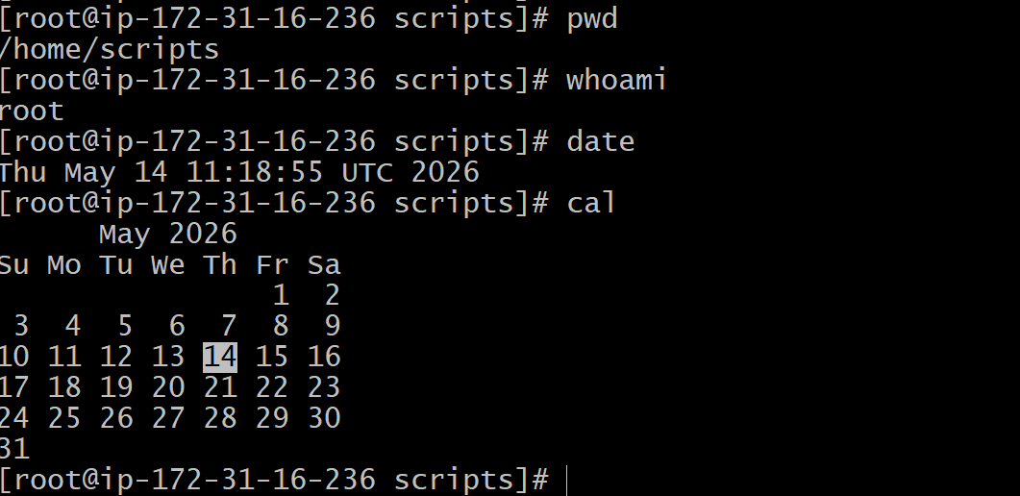
4.Script: Basic Administration Tasks:

Top
df -h
free -m
uptime
iostat

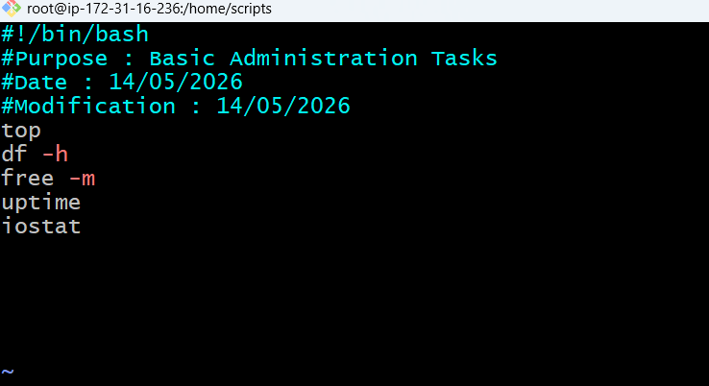
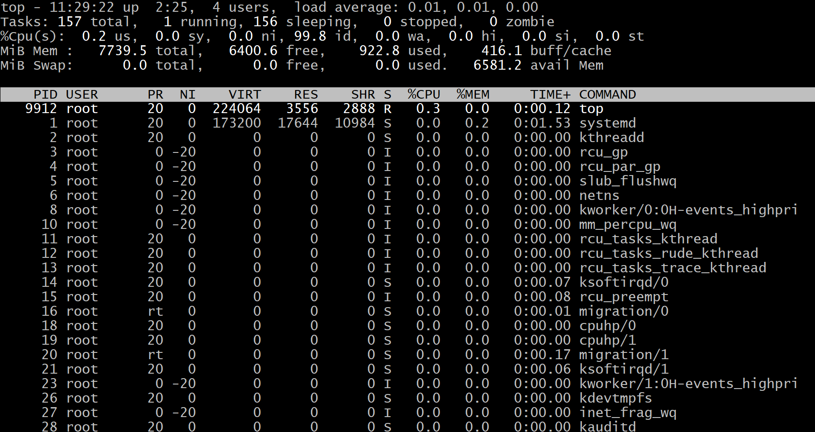

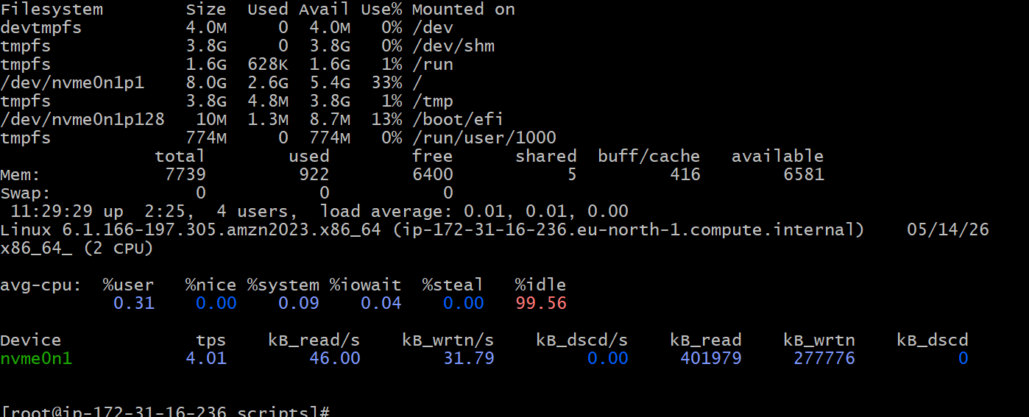
Because of running admiration its loaded fully now I change Top | head 10
Now I can see all command clearly
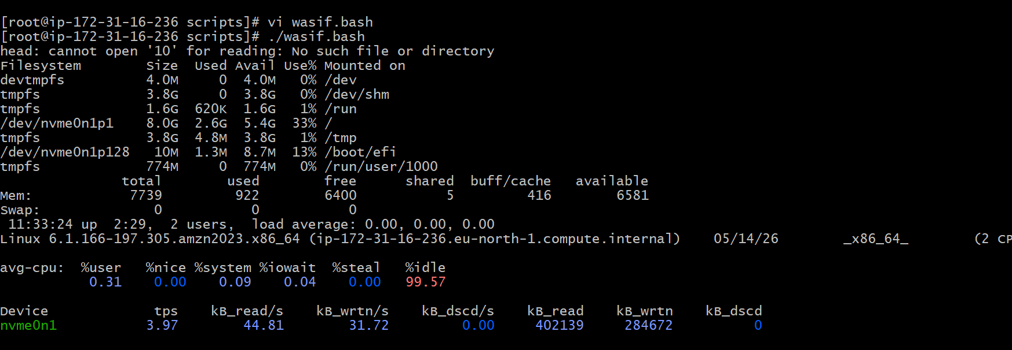

5 Script: Defining Variables:
In programming, a variable is a value that can change, depending on conditions or on information passed to the program.
Example:
#!/bin/bash
#Define Variables
p=pwd
l=ls
wi=whoami
d=date
c='cal 2026'
echo Run Variables tasks
echo
$p
$l
$wi
$d
$c

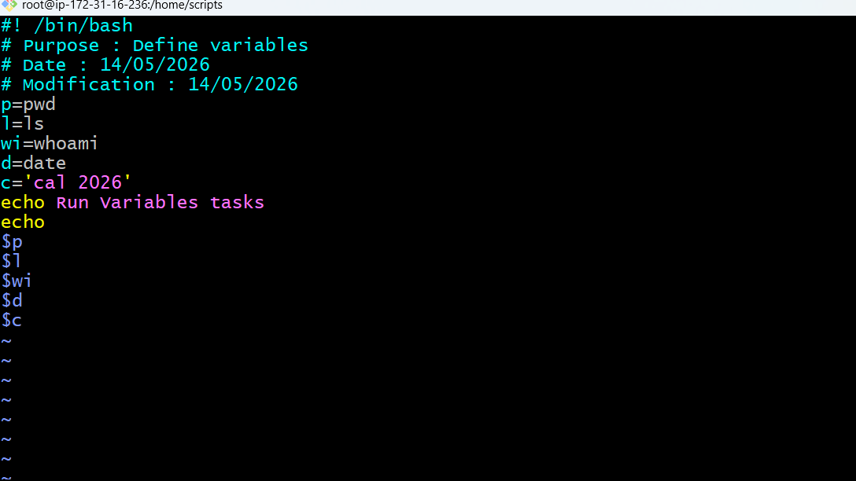
This is what actual output
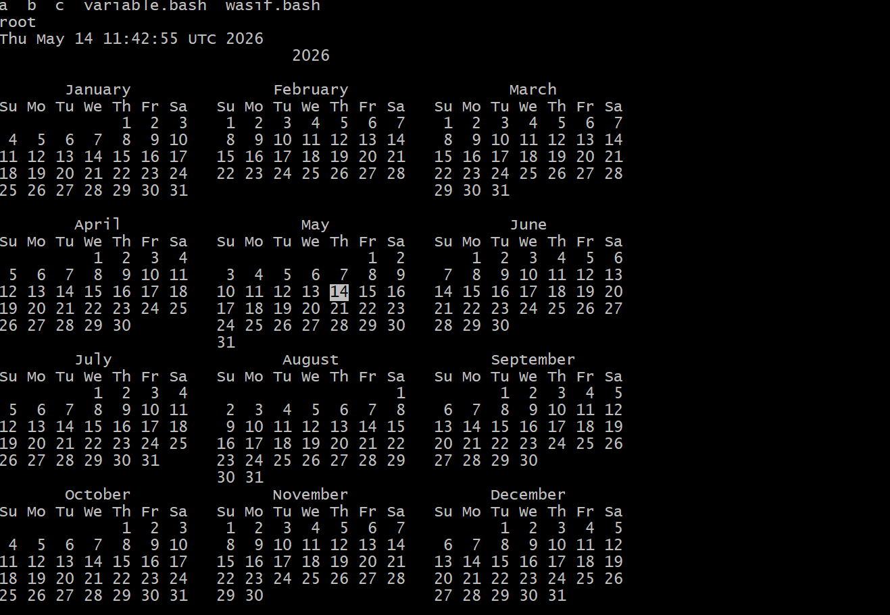
6 Script: Input/Output script:
read --> To take command from user
echo --> to print the output
Ex1:
#!/bin/bash
echo Hello, my name is Wasif
echo
echo what is your name?
read name
echo
echo Hello $name
echo
I have changed last file name as input-output then edit above text by vi command
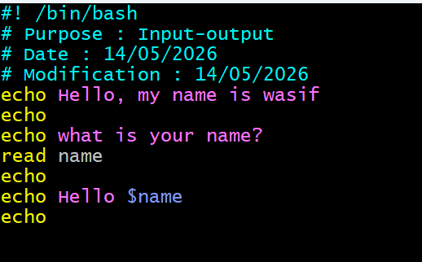

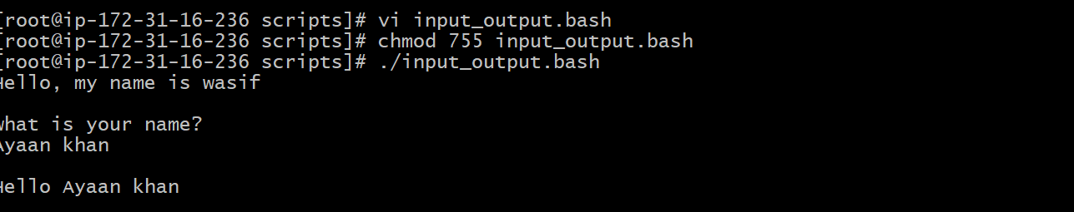
Ex2:
#!/bin/bash
#we need to use the ticks if you want to use this in echo or else not required
a=`Hostname`
echo Hello, my name is $a
echo
echo what is your name?
read b
echo
echo Hello $b
echo

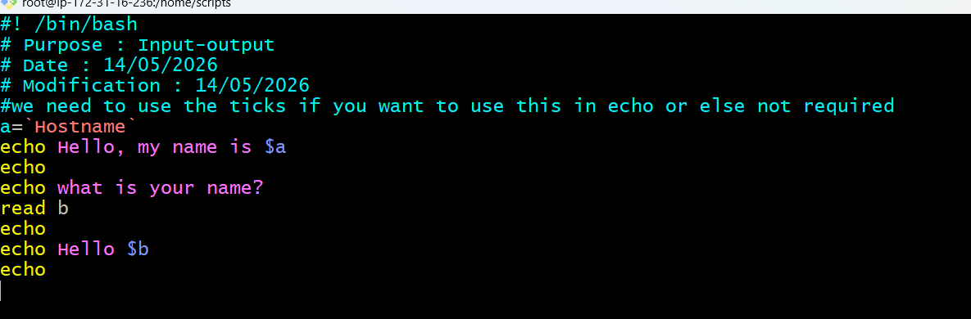
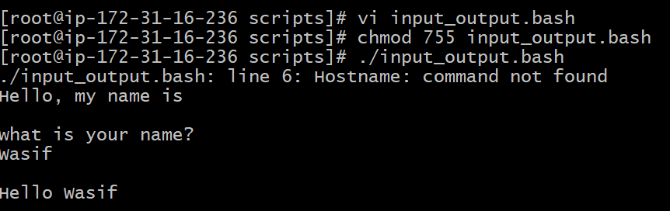
So I got error for hostname because I kept h as Capital
